**DISK MANAGEMENT – TASK**

**Create a new two hard disk name as sdb and sdc:**

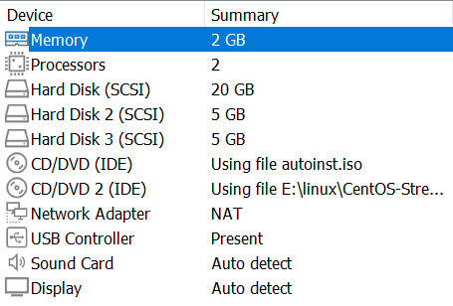

**Scan Disks:**



**#lsblk**

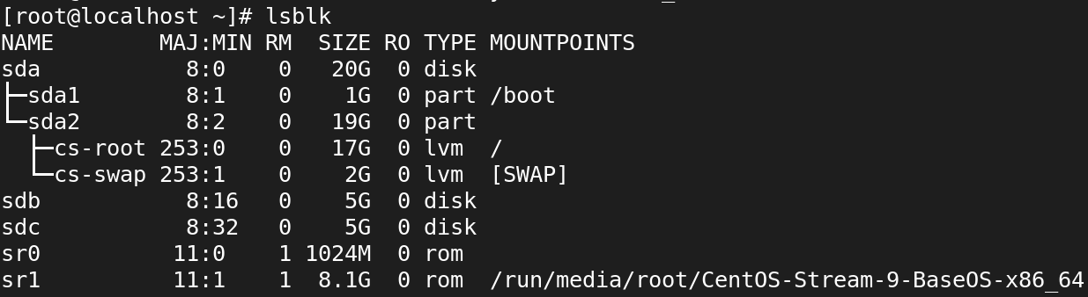

**Create partitions:**

* fdisk /dev/sdb

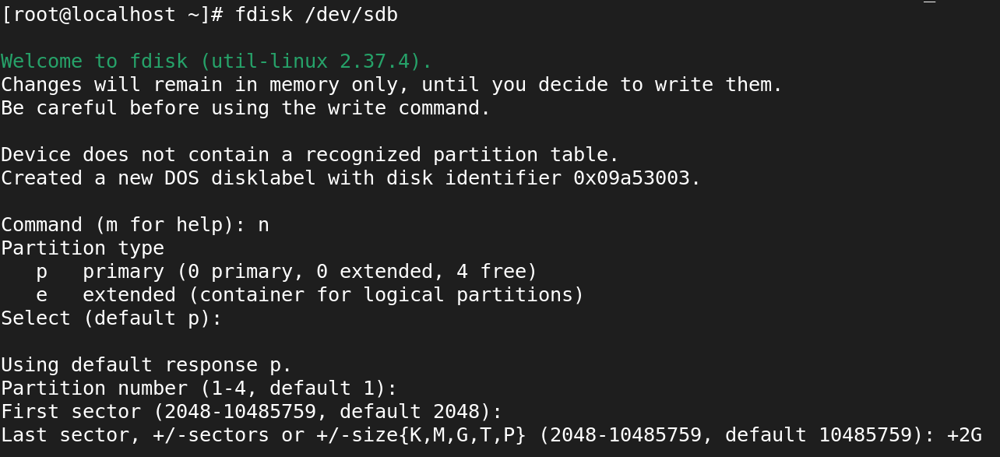

* fdisk /dev/sdc

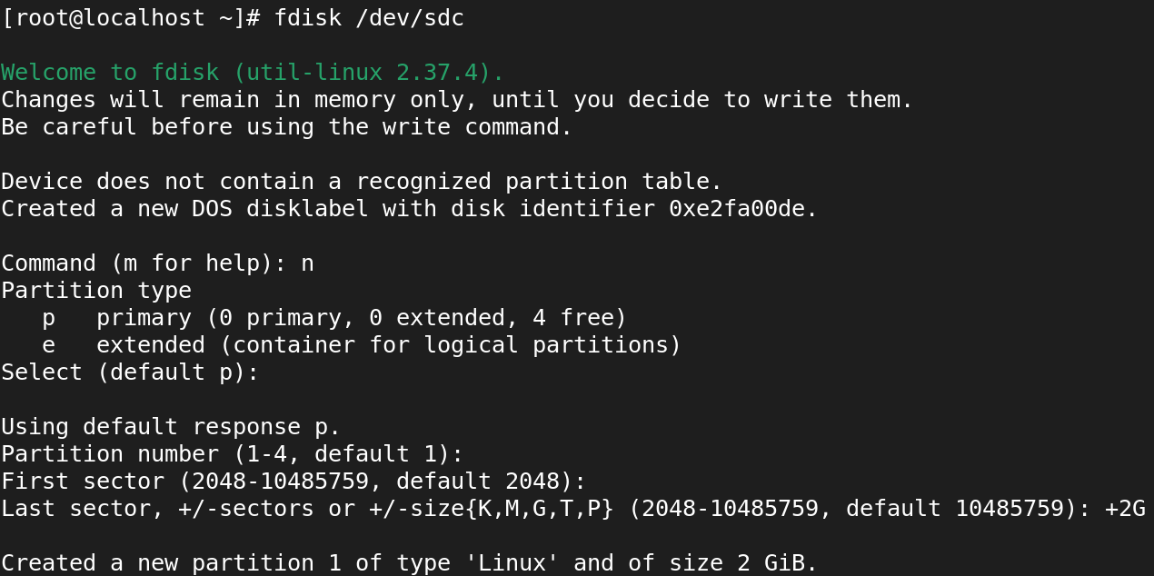

#lsblk

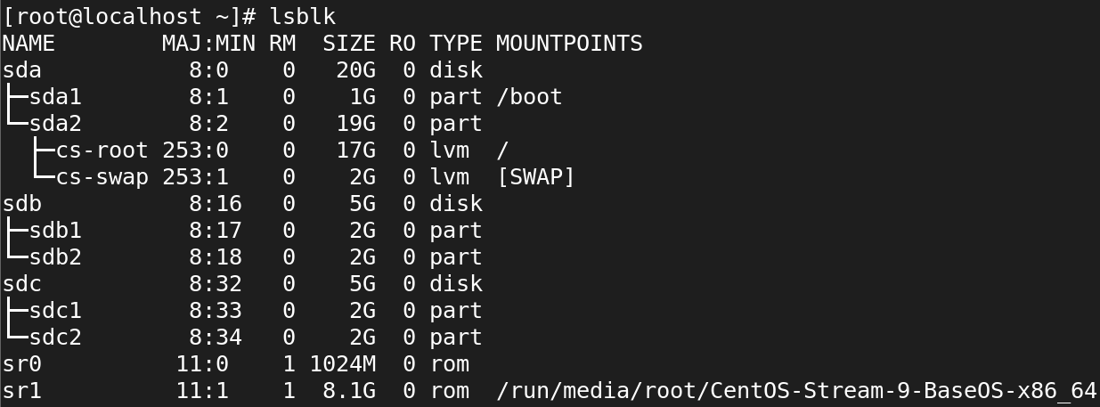

**Create a Physical Volumes for each partition:**

* + pvcreate /dev/sdb1
  + pvcreate /dev/sdb2
  + pvcreate /dev/sdc1
  + pvcreate /dev/sdc2

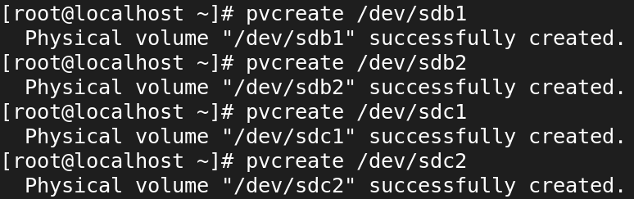

**#pvs or pvdisplay**

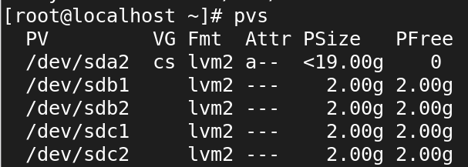

**Create single volume group for all physical volumes:**



**Create logical volumes:**

* lvcreate -L +2G -n home_lv primary_vg



* lvcreate -L +2G -n data_lv primary_vg



* lvextend-L +1G -n /dev/primary_vg/home_lv



* lvextend-L +2G -n /dev/primary_vg/data_lv



**Create file system for both Logical Volumes:**

* mkfs.xfs /dev/primary_vg/home_lv

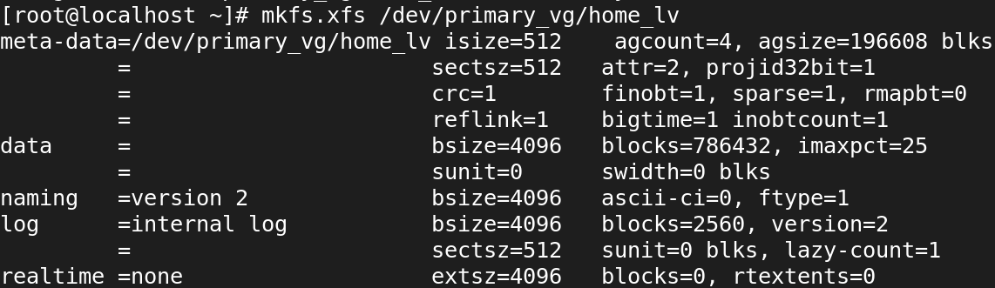

mkfs.ext4 /dev/primary_vg/data_lv

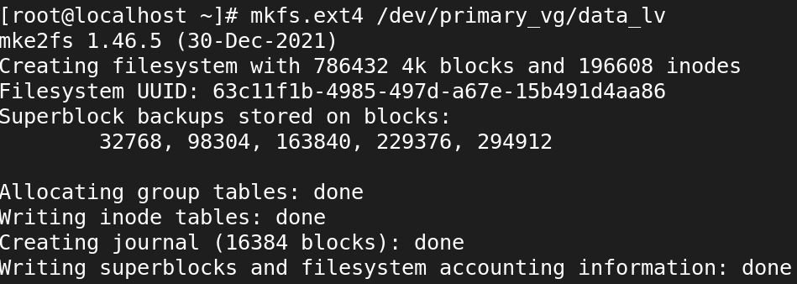

**Mounting the directories to the Logical Volumes:**

* mount /dev/primary_vg/home_lv /home/
* mount /dev/primary_vg/data_lv sz/data/

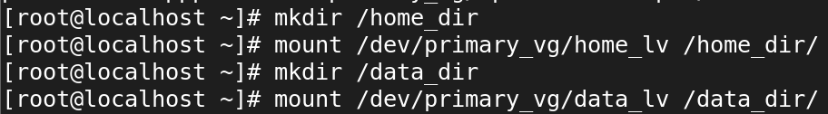

# df -Th

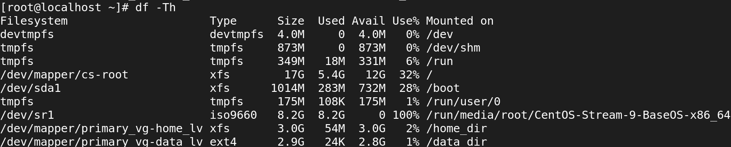

**Creating file system for extended volume:**

* xfs_growfs /dev/primary_vg/home_lv

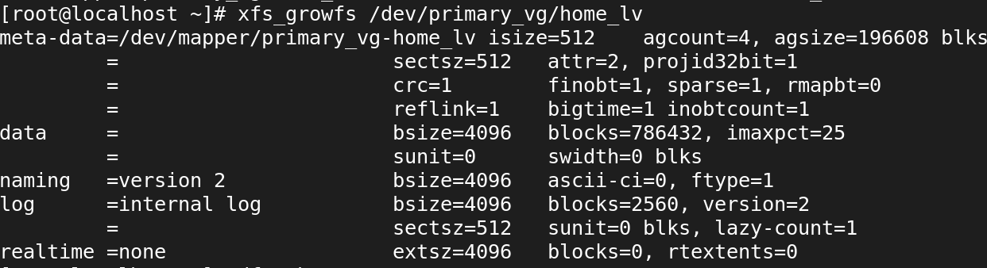

* resize2fs /dev/primary_vg/data_lv



**#df -Th**

